**H48W 35 Computing: Software Development  
Graded Unit 2**

**Project Stage: Inception Planning**

**Project Plan Report**

**Student name: Daria Vekic**

**Student number: 586661**

**Date: January / February 2023**

Table of Contents

Overview 1

Project Information 1

Scheduling 2

Gantt Chart 2

Work Breakdown Structure 4

Milestones and Deliverables 7

Main Tasks 8

Resources 12

Cost Overview 13

Conclusion 14

**Table of Figures**

Figure 1 Project Information summary 1

Figure 2 Gantt Chart showing overall schedule 3

Figure 3 WBS with subtasks collapsed 5

Figure 4 WBS showing full list of tasks 6

Figure 5 Resource list 12

Figure 6 Cost Overview Report 13

# Overview

This document relates to the Graded Unit 2 project as part of the HND Computing: Software Development H48W 35. It aims to satisfy Stage 1, Part A of the overall project by providing a report of the Project Plan and should be read in conjunction with the Action Plan Report submitted separately.

# Project Information

This Project Plan relates to the proposed new system for the client McRae & Dick Solicitors based in Forth Valley who wish for a new case management system to be built. An Action Plan has been produced alongside this Project Plan which offers:

* the project brief in full;
* an analysis of the given brief;
* the intended development route;
* the intended software development methodology to be adopted;
* initial planning models, namely initial requirements and use case diagram;
* client interaction details;
* background research, including an investigation of similar systems;
* the overall aims of the project, specifically refined requirements and use case diagram along with a conceptual model and system proposal;
* an exhaustive list of resources; and
* a feasibility analysis.

This document concerns the overall management of the project. As such, a summary of the Project Information is shown below:

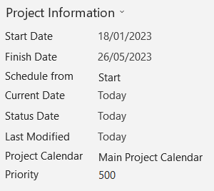

Figure Project Information summary

# Scheduling

The scheduling of a software development project is crucial to the overall success of the project. It is important that every project team member knows what must be done and when it must be completed by. The scheduling of the project also allows the team to easily view interdependencies between various tasks, thus preventing any duplication of work if a team member mistakenly thinks a task can be started earlier than planned. This would result in time and money being wasted; two constraints that can have significant impact on the project's success.

These constraints, along with scope, are commonly known as the Project Management Triangle. It is the duty of the Project Manager to balance these constraints. For example, if the project suffers scope creep, then the project will probably take longer to complete; the longer it takes to complete the project, the costlier it becomes as team members have to be paid. In an attempt to accurately estimate the right amount of time required to complete the client's project successfully and to a high quality, I have identified important tasks that will have to be carried out to produce the deliverables outlined in the Action Report and later in this document, and have also identified predecessors (task dependencies) to accurately estimate the duration of the project overall (you would not, for example, begin testing the system before the problem domain has been programmed). For a visual representation of the project schedule overall, a Gantt Chart lays out each activity's schedule.

## Gantt Chart

The following Gantt chart shows the overall scheduling for each phase of the project – Inception, Elaboration, Construction, and Transition, reflective of the chosen agile methodology – the Unified Process – with a completion date scheduled for Monday 15 May 2023. The scheduling shown below allows for slippage time and unforeseen events as the SQA project deadline is Friday 26 May 2023.

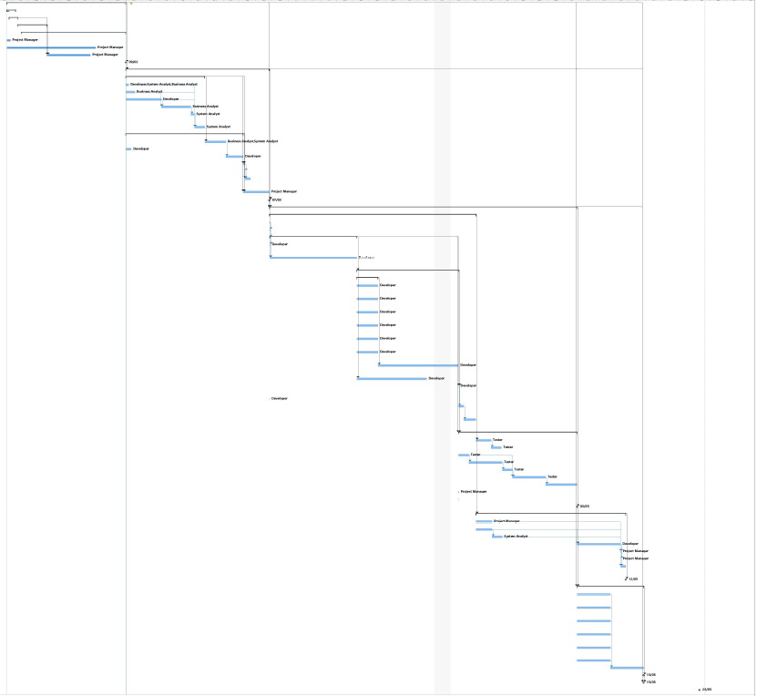

Figure Gantt Chart showing overall schedule

## Work Breakdown Structure

Another way of seeing the scheduling is the Work Breakdown Structure (WBS). This also shows the main tasks that must be undertaken to develop the client's system along with their planned start and finish dates. For readability, I have collapsed groups of subtasks in Figure 3. The full WBS listing all subtasks is shown in Figure 4. I should note here that this WBS here is to show the planned schedule of tasks. I have provided details on the main tasks in the following section, Milestones and Deliverables.

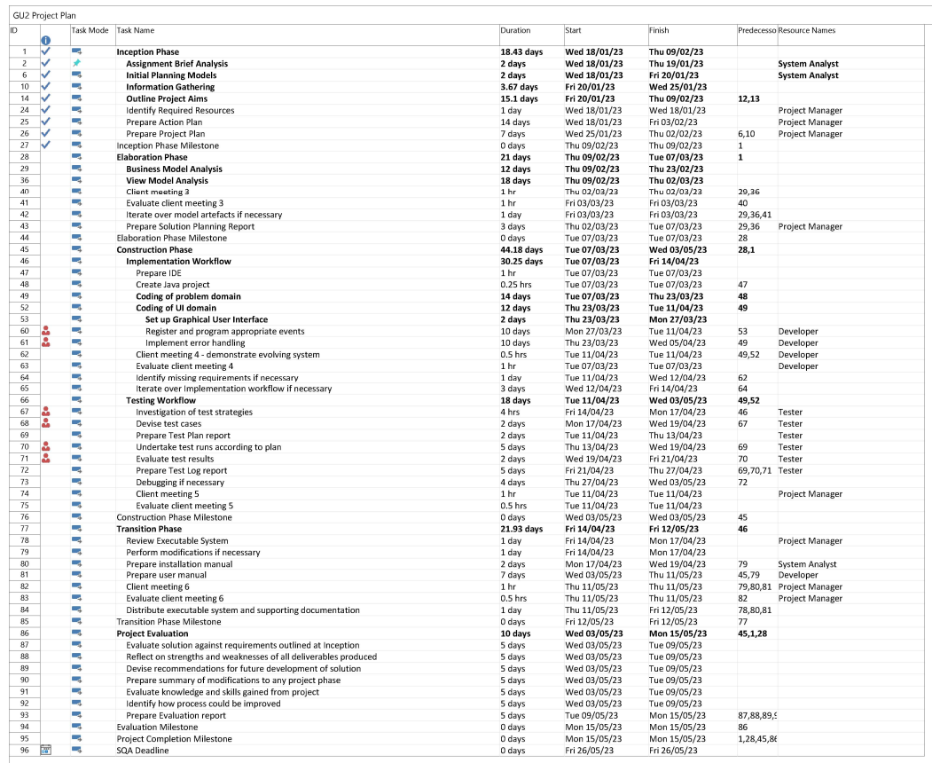

Figure WBS with subtasks collapsed

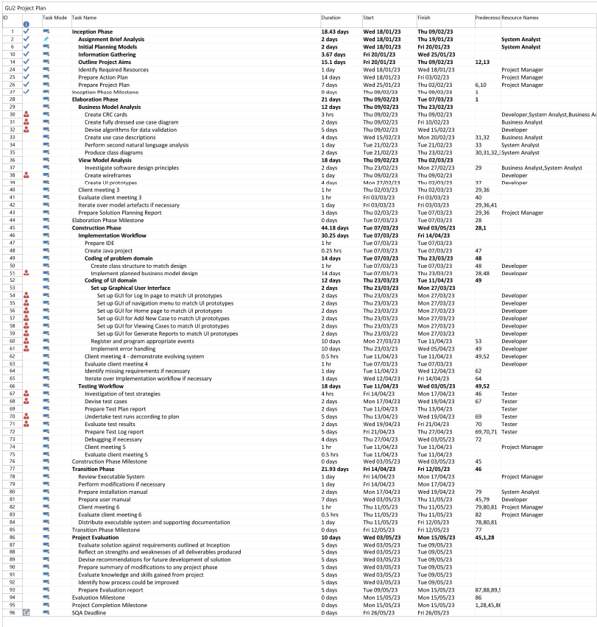

Figure WBS showing full list of tasks

# Milestones and Deliverables

The milestones and deliverables shown in this project plan reflect the chosen software development methodology, the Unified Process (UP). As explained in the accompanying Action Plan Report, the UP involves four key phases which complement 6 main workflows and 3 supporting workflows. The typical activities in each workflow may overlap, and as it is an agile approach, activities in any workflow can be repeated whenever is necessary regardless of the stage the project is at. For example, if the team have completed a full iteration of the Construction phase and discover an important requirement is missed, it is realistic and acceptable for activities undertaken in the Requirements and Analysis workflow to be revisited.

The milestones in the project identify the critical points of a project. In other words, when a milestone is achieved, an important stage of the project is complete. They do not represent actual work taking place and are therefore not allocated a human resource (the tasks that lead to a milestone will be assigned human resources, though). They simply represent an important point of progress being achieved. The deliverable is the evidence that shows the team have reached that critical point, so I have included the following table to set out the deliverables the client can expect to receive throughout the project.

|  |  |  |
| --- | --- | --- |
| **Deliverable** | **Date** | **Description** |
| 1. Action Plan Report | 10/02/2023 | Task 25 in Work Breakdown Structure  This deliverable is important for both the client and the project team. Its primary aim is to make every attempt to capture the most important requirements of the system, to assess the feasibility of the project, and to document background research relevant to the project. |
| 1. Project Plan | 10/02/2023 | Task 26 in Work Breakdown Structure |
| 1. Solution Planning Report | 08/03/2023 | Task 43 in Work Breakdown Structure  This deliverable is a continuation of developing the Action Plan Report produced during Inception. It mainly concerns the analysis and design workflows by finalising the business case of the system, or in other words answers whether the benefits of the new system will be worth it. It will also revise the risk assessment of the project.  This document includes a business model and view model analysis in the form of Class Responsibilities Collaborator cards, elaborated use case diagrams, use case descriptions, class diagrams, wireframes, and UI prototypes.  Overall, any ambiguities are addressed and clarified in this deliverable. |
| 1. Demonstration of evolving system | 14/04/2023 | Task 62 in Work Breakdown Structure  The purpose of this deliverable is to show the progress made on the client's evolving system and is also an opportunity for the client to provide feedback on any features of the system that they like or dislike. |
| 1. Executable System | 18/05/2023 | Task 84 in Work Breakdown Structure  This is the end product of the entire project. |
| 1. Installation Manual | 18/05/2023 | Task 84 in Work Breakdown Structure  This deliverable will provide step by step instructions on how to install the new system. This is as important as the new system itself as it would be of no use to the client if there is no guidance on how to install the system. |
| 1. User manual | 18/05/2023 | Task 84 in Work Breakdown Structure  This deliverable will provide helpful information on how to use the new system. It will be written in a non‑technical manner to ensure users with varying levels of IT competency can comprehend and use the system effectively. |

# Main Tasks

I have already touched upon the tasks involved to develop the client's new system when detailing the project's scheduling. A full Work Breakdown Structure is included earlier in this document. However, for clarity and thoroughness I have set out below a fuller explanation of what the key tasks involve and why they have been included.

| **Workflow** | **Task** | **Reasoning** |
| --- | --- | --- |
| Requirements and Analysis | Assignment Brief Analysis | * Key activity in Inception phase * Crucial to developing our understanding of what the client wants * Leads smoothly into establishing initial requirements of the system * A necessary section in the Action Report deliverable * Involves subtasks of textual analysis on project brief and investigating potential development routes and potential methodologies |
| Requirements and Analysis  Business Modelling | Initial Planning Models | * Key activity in Inception and Elaboration phase * Establishes team's interpretation of the basic requirements of the system * Initial requirements allow us to create a basic use case diagram * This can be used as a method of communication and is presented to client who can highlight if team's interpretation is accurate or not * Ensures we are capturing the basic functional requirements of the system * UP is agile, so missing requirements here will not result in inevitable failure – we can iterate over the workflows |
| Requirements and Analysis  Business Modelling | Information Gathering | * Key activity in Inception phase * Subtasks involve client meetings; presenting the team's interpretation of the brief to confirm basic requirements of new system * Background research to enable team to gain an understanding of the business area in a wider context * Helpful to develop our understanding of the end user which allows us to tailor features of the system according to IT skill level of end user * Also helpful in ascertaining why the system is useful to the business in the first place – questions what benefits and value the proposed system will bring to the client * Investigation of similar systems further enables the team to pinpoint what works well and is therefore worth implementing; likewise, what are current pain points of these systems that our team can modify or improve upon |
| Requirements and Analysis | Outline Project Aims | * Key activity in Inception and Elaboration phase * Take all information that has been collated so far and re‑evaluate the top‑level requirements set out in initial planning models * Refines the basic requirements by adding extra detail * Refined requirements are then evaluated and prioritised, so the team know what functionality is especially important in the system * Refined requirements can then be translated into a refined use case diagram, which should be presented to the client at the second meeting * Feasibility Analysis produced to identify the benefits, risks, and overall viability of the proposed project * Culminates in Action Plan and Project Plan; the former containing documentation of all tasks mentioned above, the latter containing details relevant to the management of the project. |
| Business Modelling  Requirements  Analysis & Design  Implementation  Testing  Configuration  Change Management | Business Model Analysis | * Key activity in Inception and Elaboration phases * Continuation of developing the Action Report to identify precisely the specific functional and non‑functional requirements * Involves creation of CRC cards * If ambiguities still exist, they should be addressed at this point * Creation of fully dressed use case diagram shows everything the team believe a user should have the ability to do * We can present this to the client for confirmation that the requirements have definitely been captured * The required algorithms for data validation can be devised to allow for fully dressed use case descriptions to be produced * We can then perform a second textual analysis on these use case descriptions, and from this detailed class diagrams can be created * Programming can happen concurrently in this workflow, hence the inclusion of the Testing workflow |
| Business Modelling  Requirements  Analysis & Design  Implementation  Testing  Configuration  Change Management | View Model Analysis | * Key task throughout Elaboration phase * An investigation into software design principles to allow the most appropriate design work to be carried out * Basic wireframes are produced * Regular client interaction takes place to ensure client approves of design decisions * Wireframes are elaborated upon * User Interface prototypes are created; shown to client for approval and feedback * Team may iterate over the workflows to ensure client satisfaction; supporting workflows configuration and change management are relevant here as client feedback or unforeseen events may cause the need for extra iterations |
| Implementation  Testing | Construction of problem and UI domain | * Key task in Construction phase * Likely to be a task with longer duration * The Developer will implement a class structure to match business model design and will set up the Graphical User Interface to reflect the UI prototypes created in the View Model Analysis * The Developer will also implement error handling, so the system only accepts data it is supposed to * Regular client update meetings will help in identifying any missing requirements |
| Deployment  Change Management | Review Executable System | * Key task in Transition phase * Before we launch the new system, it should be reviewed to ensure all is in good order before the client can use it * If there are any issues arising, modifications should be performed |
| Deployment | Preparation of Supporting Documentation | * Key task in Transition phase * Involves the preparation of any documentation that will help the client to get the most out of the new system, specifically an installation manual and a user manual |
| Deployment | Distribute Executable System and Supporting Documentation | * Key task in Transition phase * The handing over of the end product to the client |

# Resources

An exhaustive list of all resources required for successful completion of this project has been provided in the accompanying Action Plant Report. The resources which have a cost attached to them have been incorporated into the Project Plan, as shown below, to allow for a more accurate cost estimation:

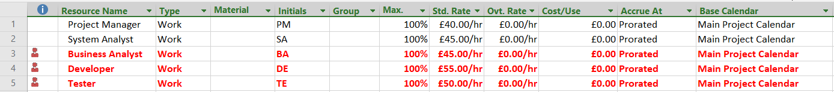

Figure Resource list

The resources coloured red are overallocated throughout the project. However, in reality, this is an **individual** project that aims to satisfy, in part, the requirements of H48W 35 Computing: Software Development Graded Unit 2, so of course I am going to be overallocated.

# Cost Overview

I have included a cost overview report in this Project Plan to measure the predicted cost of the project against the client's budget. We can see from Figure 6 below that the cost estimation is well within the client's budget of £60,000. This allows the project team some leeway if any unforeseen events arise and more time is required on any given task. A little flexibility in the budget helps to balance the three constraints of the Project Management Triangle.

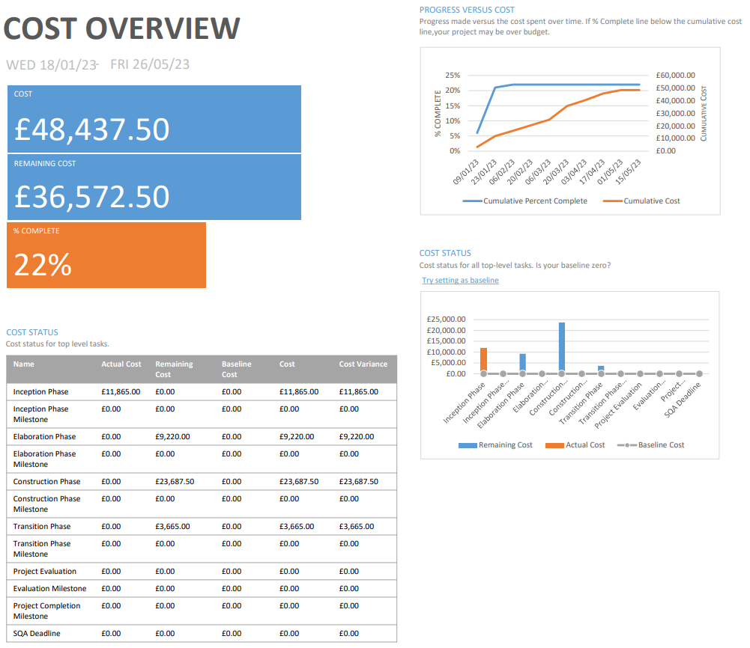

Figure Cost Overview Report

# Conclusion

This Project Plan has set out relevant information to the management of the client’s project. It has provided a summary of the project to be undertaken and has set out the predicted schedule of milestones and corresponding deliverables. The Gantt Chart shows a visual representation of the project schedule overall so all project stakeholders can see at a glance the schedule and duration of activities. This is supported by the Work Breakdown Structure which provides a list of all main tasks and subtasks along with their estimated duration and scheduling. The WBS also lays out the milestones which the project team will work towards to evidence the progress made up to that point in time. The main tasks involved in the project have been described and justified and the required human resources have also been outlined. A Cost Over Report shows the estimated cost of the entire project and shows clearly that we estimate to stay within the client’s specified budget. To conclude, this Project Plan has attempted to convey to the client and team the overall schedule of the project and the deliverables which can be expected to evidence a milestone has been achieved.